JavaFX CSS Application Design
Module 7 Programming Assignment
Author: Zachary White
Professor: Darrell Payne
Course: CSD 420 Advanced Java Programming
Date: September 15th 2026

1. Overview
This application shows how JavaFX nodes can be styled with an external CSS style sheet instead of being styled in Java code. The program displays four circles in a row. The first circle sits inside a thick black border box. The first two circles are styled with a CSS class, and the last two are styled with CSS IDs. The result matches the sample output given in the assignment.
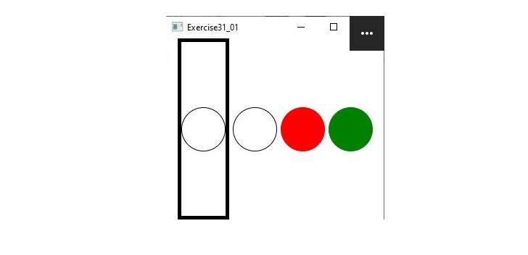
Figure 1. Sample output provided with the assignment
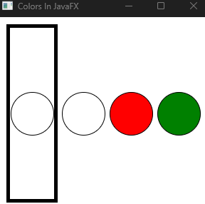
Figure 2. The running application window

2. Application Files
- Colors_in_JavaFX.java – the JavaFX program. It builds the user interface, attaches the style sheet, and runs the test code.
- mystyle.css – the external style sheet that defines the class and ID selectors used by the nodes.
Both files must be stored in the same folder so the program can find the style sheet at run time.

3. Style Sheet Design
The style sheet separates appearance from program logic. Class selectors are used for styles that are reused, such as the white circles and the border box. ID selectors are used for the red and green circles because each style belongs to exactly one node.
Selector | Type | Properties | Applied To
.border | Class | Black border color, 5px border width | Box around Circle 1
.plainStyle | Class | White fill, black stroke, 1px width | Circle 1 and Circle 2
#redStyle | ID | Red fill, black stroke, 1px width | Circle 3
#greenStyle | ID | Green fill, black stroke, 1px width | Circle 4

JavaFX uses its own CSS properties, which begin with -fx-. The properties used here are -fx-fill for the inside color of a shape, -fx-stroke for the outline color, -fx-stroke-width for the outline thickness, and -fx-border-color and -fx-border-width for the border drawn around a layout pane.

4. Program Design
The class Colors_in_JavaFX extends javafx.application.Application and overrides the start method, which is where the interface is built. The design follows these steps:
- Create the circles. Four Circle objects are created, each with a radius of 30 pixels.
- Assign styles. Circles 1 and 2 call getStyleClass().add("plainStyle"). Circles 3 and 4 call setId() with "redStyle" and "greenStyle".
- Build the border box. Circle 1 is placed inside a StackPane that uses the "border" style class. The pane is fixed at 72 by 245 pixels, which makes the tall box seen in the sample.
- Lay out the nodes. An HBox holds the border box and the other three circles side by side with 6 pixels of spacing. It is centered with Pos.CENTER so every circle lines up at the same vertical middle, and it has 10 pixels of padding.
- Attach the style sheet. The HBox is placed in a 300 by 270 Scene, and mystyle.css is added to the scene's style sheet list.
- Show the window. The scene is set on the primary stage, which is titled "Colors In JavaFX" and then displayed.
- Run the tests. After the stage is shown, the runTests method checks that everything was applied correctly.

5. Test Design
The runTests method is called after the window is shown so the CSS has already been applied to the nodes. It runs eight checks and prints PASSED or FAILED for each one to the console.
Test | What It Verifies | How It Checks
1 | The external stylesheet loaded | Scene's stylesheet list is not empty
2 | Circle 1 uses the .plainStyle class | getStyleClass() contains "plainStyle"
3 | Circle 2 uses the .plainStyle class | getStyleClass() contains "plainStyle"
4 | Circle 3 has the #redStyle ID | getId() equals "redStyle"
5 | Circle 4 has the #greenStyle ID | getId() equals "greenStyle"
6 | CSS actually applied the fill colors | Fill of circles 1, 3 and 4 is white, red and green
7 | Circle 1 is inside the .border box | Box has the "border" class and contains Circle 1

Tests 1 through 5 confirm the setup is correct. Tests 6 through 7 confirm the actual result by reading the fill colors, the border box, and the stroke widths after the style sheet was applied, which proves the CSS took effect and not just that the names were assigned.

6. Test Results
The program was compiled and run from the command line. The console output below shows the tests passing.
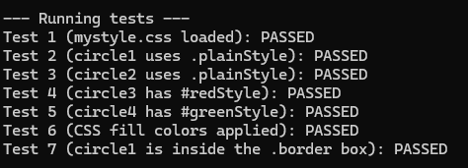
Figure 3. Console output of the test results

7. Compile and Run
The program is compiled and run with the JavaFX SDK on the module path:
javac --module-path %PATH_TO_FX% --add-modules javafx.controls Colors_in_JavaFX.java
java --module-path %PATH_TO_FX% --add-modules javafx.controls Colors_in_JavaFX

8. Conclusion
This assignment showed how an external CSS file keeps styling separate from Java code. Class selectors work well for a style shared by many nodes, and ID selectors work well for a style that belongs to a single node. The built-in tests confirmed that the style classes, IDs, border box, and colors were all applied as intended.

9. References
Liang, Y. D. (2023). Introduction to Java programming and data structures (13th ed.). Pearson.
Oracle. (n.d.). JavaFX CSS reference guide. https://docs.oracle.com/javase/8/javafx/api/javafx/scene/doc-files/cssref.html
Tutorialspoint. (n.d.). JavaFX - CSS. https://www.tutorialspoint.com/javafx/javafx_css.htm
Bellevue University (2026) – related course materials for module 7.

